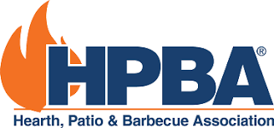

Stay up-to-date on legislation and regulations that impact
your business and the hearth and barbecue industries!

Whether you are a retailer, distributor, manufacturer, or consumer of these products, your voice is needed to protect this industry.
Scan the QR code below to sign up for alerts of legislative action in your state or local governments.

